The Collections Framework
The Java Collections Framework provides a set of interfaces (like List, Set, and Map) and a set of classes (ArrayList, HashSet, HashMap, etc.) that implement those interfaces.
All of these are part of the java.util package.
They are used to store, search, sort, and organize data more easily - all using standardized methods and patterns.
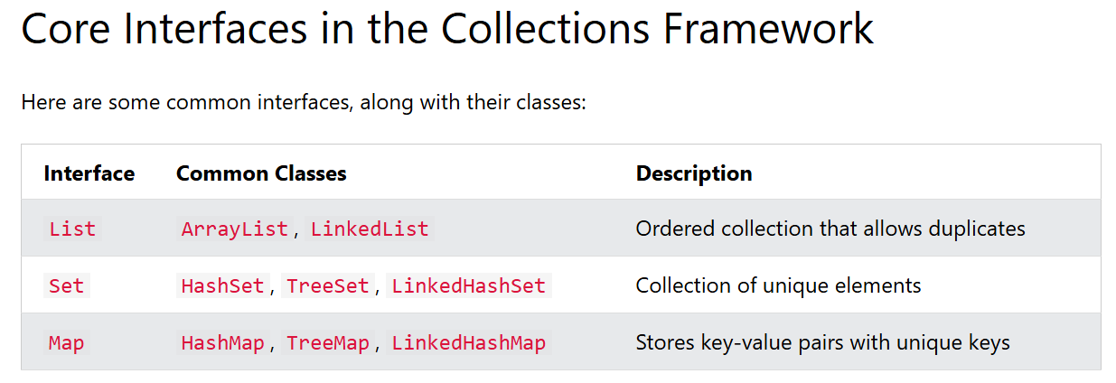
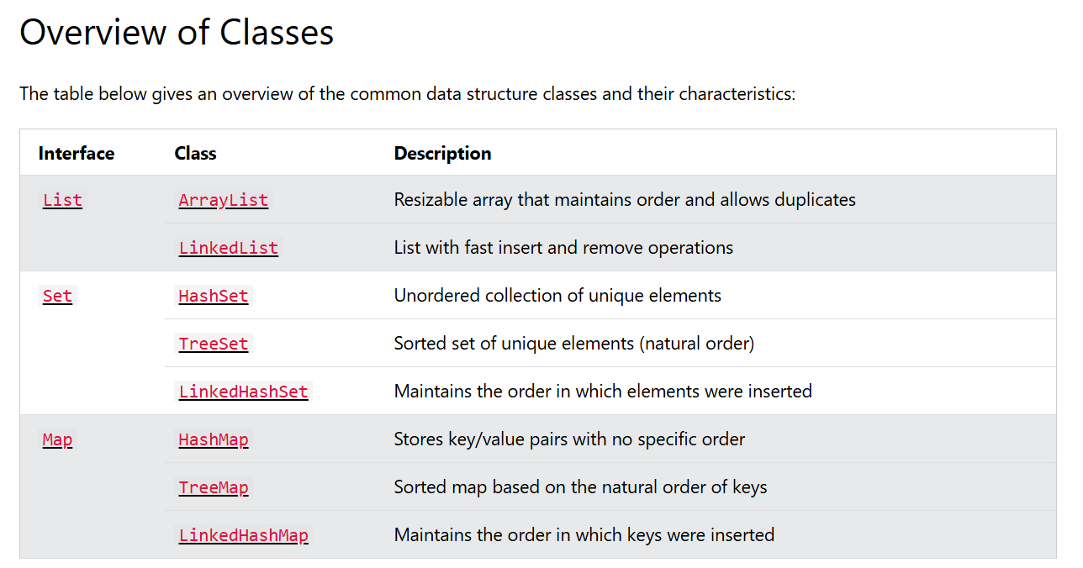

Java List Interface
The List interface is part of the Java Collections Framework and represents an ordered collection of elements.
You can access elements by their index, add duplicates, and maintain the insertion order.
Since List is an interface, you cannot create a List object directly.
Instead, you use a class that implements the List interface, such as:
- ArrayList - like a resizable array with fast random access
- LinkedList - like a train of cars you can easily attach or remove
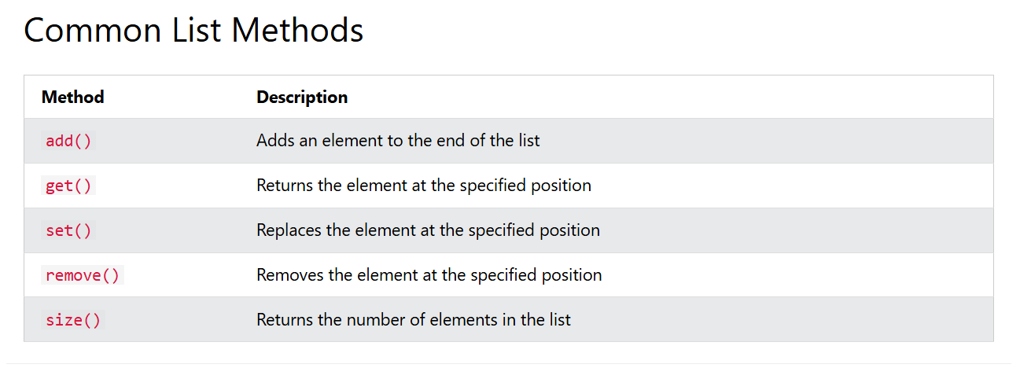
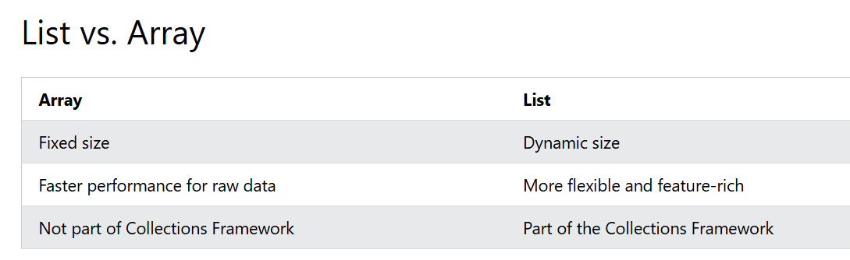

Java ArrayList
An ArrayList is like a resizable array. It is part of the java.util package and implements the List interface.
The difference between a built-in array and an ArrayList in Java, is that the size of an array cannot be modified (if you want to add or remove elements to/from an array, you have to create a new one). While elements can be added and removed from an ArrayList whenever you want.
import java.util.ArrayList; // Import the ArrayList class
ArrayList<String> cars = new ArrayList<String>(); // Create an ArrayList object

import java.util.ArrayList;

public class ArrayListClass {

public static void main(String[] args) {

ArrayList<String> cars = new ArrayList<String>();
cars.add("Volvo");
cars.add("BMW");
cars.add("Ford");
cars.add("Mazda");
System.out.println(cars); // [Volvo, BMW, Ford, Mazda]

cars.add(0,"Huyndai"); // Add new car at first position
System.out.println(cars); // [Huyndai, Volvo, BMW, Ford, Mazda]

cars.get(0); // Get the first element
System.out.println(cars.get(0)); // Huyndai

cars.set(0, "Opel"); //To modify an element, use the set() method and refer to the index number:
System.out.println(cars); // [Opel, Volvo, BMW, Ford, Mazda]

cars.remove(0); //To remove an element, use the remove() method and refer to the index number:
System.out.println(cars); // [Volvo, BMW, Ford, Mazda]

cars.size(); //To find out how many elements an ArrayList have, use the size method:
System.out.println(cars.size()); //4

cars.clear(); // To remove all the elements in the ArrayList, use the clear() method:
System.out.println(cars.size()); // 0
System.out.println(cars); // [ ]

}

}

- Looping ArrayList

import java.util.ArrayList;

public class LoopThroughanArrayList {

public static void main(String[] args) {
ArrayList<String> cars = new ArrayList<String>();
cars.add("Volvo");
cars.add("BMW");
cars.add("Ford");
cars.add("Mazda");
// for (int i = 0; i < cars.size(); i++) {
// System.out.println(cars.get(i));
//
// }
// for each loop

for(String car:cars) {
System.out.println(car);
}

ArrayList<Integer> myNumbers = new ArrayList<Integer>();
myNumbers.add(10);
myNumbers.add(15);
myNumbers.add(20);
myNumbers.add(25);
for (int i : myNumbers) {
System.out.println(i);
}
}
}

- Sorting ArrayList in Ascending and Descending order:

import java.util.ArrayList;
import java.util.Collections;
import java.util.List;

public class SortArrayList {

public static void main(String[] args) {
// List<String> cars = new ArrayList<>(); //Sometimes you will see both List and ArrayList in Java code
ArrayList<String> cars = new ArrayList<>();
cars.add("Suzuki");
cars.add("Volvo");
cars.add("BMW");
cars.add("Ford");
cars.add("Mazda");

Collections.sort(cars); //Ascending order
System.out.println(cars); // [BMW, Ford, Mazda, Suzuki, Volvo]

Collections.sort(cars, Collections.reverseOrder()); //Descending order
System.out.println(cars); // [Volvo, Suzuki, Mazda, Ford, BMW]

}

}

Java LinkedList
The LinkedList class is almost identical to the ArrayList.
import java.util.LinkedList;
public class Main {
public static void main(String[] args) {
LinkedList<String> cars = new LinkedList<String>();
cars.add("Volvo");
cars.add("BMW");
cars.add("Ford");
cars.add("Mazda");
System.out.println(cars);
}
}

ArrayList vs. LinkedList
The LinkedList class is a collection which can contain many objects of the same type, just like the ArrayList.
The LinkedList class has the same methods as ArrayList because both follow the List interface. This means you can add, change, remove, or clear elements in a LinkedList just like you would with an ArrayList.
However, while the ArrayList class and the LinkedList class can be used in the same way, they are built very differently.

How the ArrayList works
The ArrayList class has a regular array inside it. When an element is added, it is placed into the array. If the array is not big enough, a new, larger array is created to replace the old one and the old one is removed.

How the LinkedList works
The LinkedList stores its elements in "containers." The list has a link to the first container and each container has a link to the next container in the list. To add an element to the list, the element is placed into a new container and that container is linked to one of the other containers in the list.
When To Use
Use an ArrayList for storing and accessing data, and LinkedList to manipulate data.
LinkedList Methods
For many cases, the ArrayList is more efficient as it is common to need access to random elements in the list, but the LinkedList provides several methods to do certain operations more efficiently:
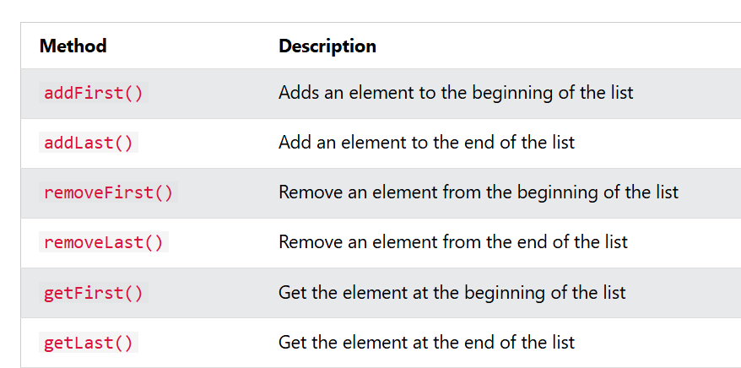

import java.util.LinkedList;

public class LinkedListClass {
public static void main (String [] args) {

LinkedList<String> cars = new LinkedList<>();
cars.add("Suzuki");
cars.add("Volvo");
cars.add("Huyndai");
System.out.println(cars); //[Suzuki, Volvo, Huyndai]

cars.addFirst("Mazda"); // Adds an element to the beginning of the list
System.out.println(cars); //[Mazda, Suzuki, Volvo, Huyndai]

cars.addLast("Jeep"); // Add an element to the end of the list
System.out.println(cars); // [Mazda, Suzuki, Volvo, Huyndai, Jeep]

cars.getFirst(); // Get the element at the beginning of the list
System.out.println(cars.getFirst()); // Mazda

cars.getLast(); // Get the element at the end of the list
System.out.println(cars.getLast()); // Jeep

cars.removeFirst(); //Remove an element from the beginning of the list
System.out.println(cars); //[Suzuki, Volvo, Huyndai, Jeep]

cars.removeLast(); //Remove an element from the end of the list
System.out.println(cars); //[Suzuki, Volvo, Huyndai]
}
}

Java Set Interface
The Set interface is part of the Java Collections Framework and is used to store a collection of unique elements.
Unlike a List, a Set does not allow duplicates, and it does not preserve the order of elements (unless you're using TreeSet or LinkedHashSet).
Common classes that implement Set:
- HashSet - fast and unordered
- TreeSet - sorted set
- LinkedHashSet - ordered by insertion
Tip: Use a Set when you need to store unique values only
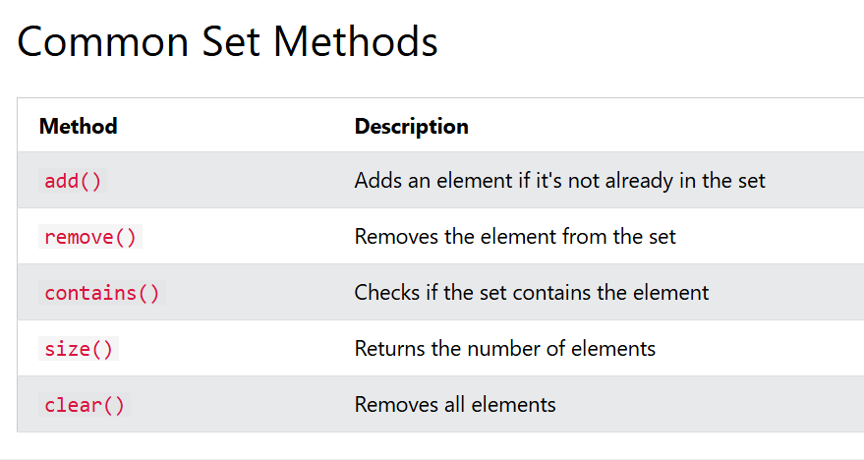

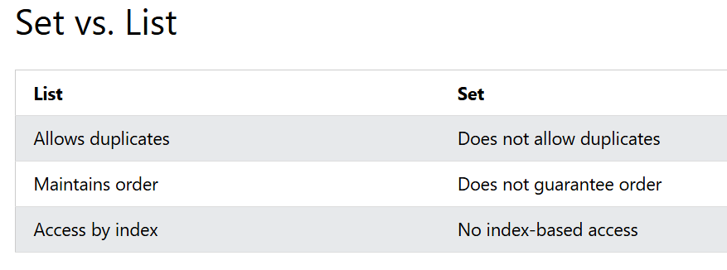
A HashSet is a collection of elements where every element is unique.
HashSet<String> cars = new HashSet<>();
cars.add("Honda");
cars.add("Hyundai");
cars.add("Volvo");
cars.add("Honda"); // duplicate
cars.add("Mazda");
System.out.println(cars);

System.out.println(cars.contains("Mazda")); // To check whether an element exists in a HashSet

System.out.println(cars.size()); //return size of set

cars.remove("Volvo");
System.out.println(cars); // Removes the element from the set

cars.clear(); //To remove all elements, use the clear() method
System.out.println(cars);
System.out.println(cars.size());

Java TreeSet
A TreeSet is a collection that stores unique elements in sorted order.
It is part of the java.util package and implements the Set interface.
Tip: Unlike HashSet, which has no order, TreeSet keeps its elements sorted automatically.
public static void main(String[] args) {
TreeSet<String> cars = new TreeSet<>();
cars.add("Volvo");
cars.add("BMW");
cars.add("Ford");
cars.add("BMW"); // Duplicate
cars.add("Mazda");

System.out.println(cars); //[BMW, Ford, Mazda, Volvo]

cars.contains("Ford"); // Use contains() to check if an element exists:
System.out.println(cars.contains("Ford")); //true

cars.remove("BMW"); // to remove element from set
System.out.println(cars); //[Ford, Mazda, Volvo]

}

Java LinkedHashSet
A LinkedHashSet is a collection that stores unique elements and remembers the order they were added.
It is part of the java.util package and implements the Set interface.
Tip: Use LinkedHashSet when you want a set that does not allow duplicates and keeps the original insertion order.
public static void main(String[] args) {

LinkedHashSet<String> cars = new LinkedHashSet<>();
cars.add("Honda");
cars.add("Hyundai");
cars.add("BMW");
cars.add("Honda"); //duplicate

System.out.println(cars); //[Honda, Hyundai, BMW]

System.out.println(cars.contains("BMW")); // to check existence

cars.remove("BMW");
System.out.println(cars); //[Honda, Hyundai]

}

Java Map Interface
The Map interface is a part of the Java Collections Framework and is used to store key-value pairs. Each key must be unique, but values can be duplicated.
A Map is useful when you want to associate a key (like a name or ID) with a value (like an age or description).
Common classes that implement Map:
- HashMap - fast and unordered
- TreeMap - sorted by key
- LinkedHashMap - ordered by insertion
Tip: Use a Map when you want to associate values with unique keys, like storing user IDs with names.
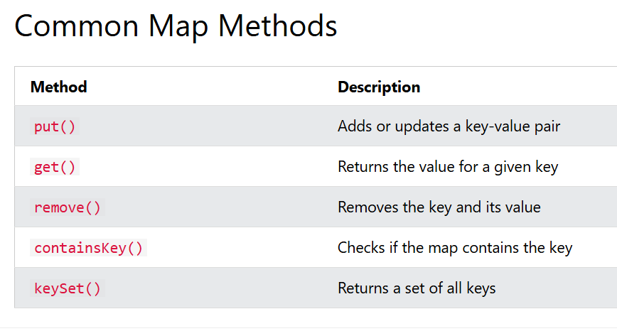
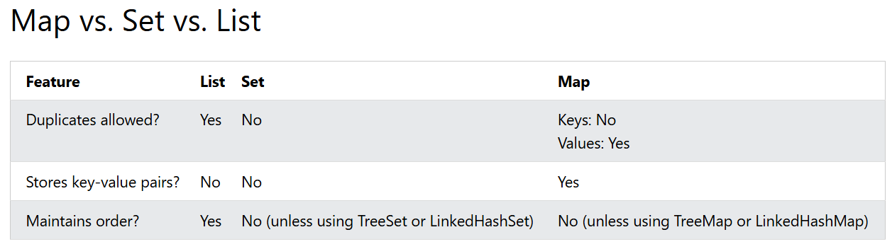

Java HashMap
A HashMap stores items in key/value pairs, where each key maps to a specific value.
It is part of the java.util package and implements the Map interface.
Instead of accessing elements by an index (like with ArrayList), you use a key to retrieve its associated value.
A HashMap can store many different combinations, such as:
- String keys and Integer values
- String keys and String values
HashMap<String, String> capitalCities = new HashMap<>();

// Add keys and values (Country, City)
capitalCities.put("England", "London");
capitalCities.put("India", "New Dehli");
capitalCities.put("Norway", "Oslo");
capitalCities.put("Austria", "Wien");
capitalCities.put("Norway", "Oslo"); // Duplicate
capitalCities.put("USA", "Washington DC");

System.out.println(capitalCities);// {Austria=Wien, USA=Washington DC, Norway=Oslo, England=London, India=New
// Dehli}

System.out.println(capitalCities.keySet()); // [Austria, USA, Norway, England, India] return only keys

System.out.println(capitalCities.values()); // [Wien, Washington DC, Oslo, London, New Dehli]

System.out.println(capitalCities.containsKey("India")); // true

System.out.println(capitalCities.containsValue("Oslo")); // true

capitalCities.get("England"); // To access a value in the HashMap, use the get() method and refer to its key:
System.out.println(capitalCities.get("England")); // London

capitalCities.remove("USA");
System.out.println(capitalCities); // {Austria=Wien, Norway=Oslo, England=London, India=New Dehli}

capitalCities.clear();
System.out.println(capitalCities); // to clear the map

Java TreeMap
A TreeMap is a collection that stores key/value pairs in sorted order by key.
It is part of the java.util package and implements the Map interface.
Tip: Unlike HashMap, which does not maintain order, TreeMap keeps its keys sorted.
public static void main(String[] args) {
TreeMap<String, String> capitalCities = new TreeMap<>();
capitalCities.put("England", "London");
capitalCities.put("India", "New Dehli");
capitalCities.put("Austria", "Wien");
capitalCities.put("Norway", "Oslo");
capitalCities.put("Norway", "Oslo"); // Duplicate
capitalCities.put("USA", "Washington DC");

System.out.println(capitalCities); //{Austria=Wien, England=London, India=New Dehli, Norway=Oslo, USA=Washington DC}

capitalCities.get("India");
System.out.println(capitalCities.get("India")); //New Dehli

System.out.println(capitalCities.remove("USA")); //Washington DC

capitalCities.clear();
System.out.println(capitalCities); // empty map
}

Java LinkedHashMap
A LinkedHashMap stores keys and values, and keeps them in the same order you put them in.
It is part of the java.util package and implements the Map interface.
Tip: Use LinkedHashMap when you want predictable iteration order (insertion order).
LinkedHashMap<String, String> capitalCities = new LinkedHashMap<>();

capitalCities.put("England", "London");
capitalCities.put("India", "New Dehli");
capitalCities.put("Austria", "Wien");
capitalCities.put("Norway", "Oslo");
capitalCities.put("Norway", "Oslo"); // Duplicate
capitalCities.put("USA", "Washington DC");

System.out.println(capitalCities); // As per insertion order {England=London, India=New Dehli, Austria=Wien, Norway=Oslo, USA=Washington DC}

System.out.println(capitalCities.get("India")); // New Dehli

System.out.println(capitalCities.remove("USA")); //Washington DC

capitalCities.clear();
System.out.println(capitalCities); // Empty map

Java Iterator
An Iterator is an object that can be used to loop through collections, like ArrayList and HashSet.
It is called an "iterator" because "iterating" is the technical term for looping.
To use an Iterator, you must import it from the java.util package.
public static void main(String[] args) {
// Make a collection
ArrayList<String> cars = new ArrayList<String>();
cars.add("Volvo");
cars.add("BMW");
cars.add("Ford");
cars.add("Mazda");

// Get the iterator
Iterator<String> it = cars.iterator();

// Print the first item
System.out.println(it.next());

// Loop through a collection
while(it.hasNext()) {
System.out.println(it.next());
}
}

